**ASSIGNMENT: 2**

**CREATE DATABASE:**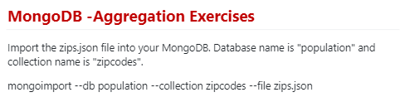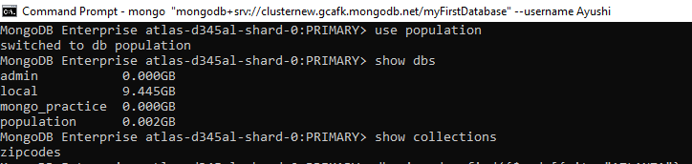

1. MongoDB Enterprise atlas-d345al-shard-0:PRIMARY> **use population**

**switched to db population**

1. MongoDB Enterprise atlas-d345al-shard-0:PRIMARY> **show dbs**

**admin 0.000GB**

**local 9.445GB**

**mongo_practice 0.000GB**

**population 0.002GB**

1. MongoDB Enterprise atlas-d345al-shard-0:PRIMARY> **show collections**

**Zipcodes**

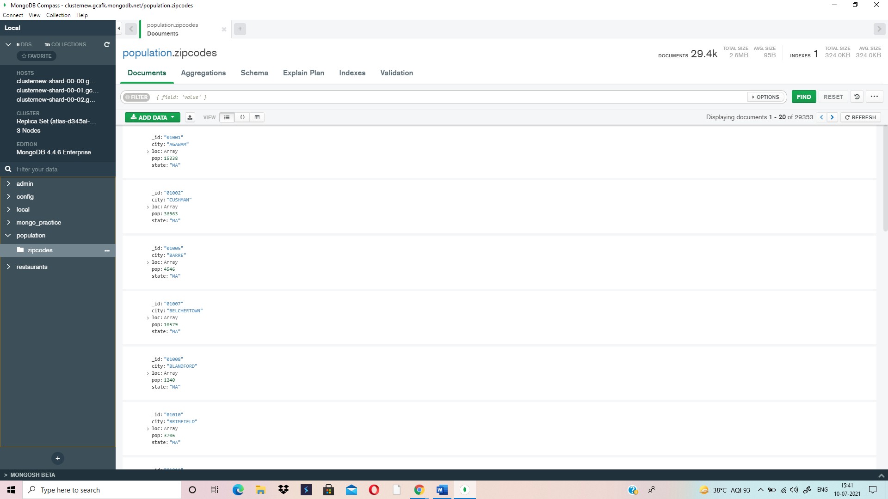

**ATLANTA POPULATION:**

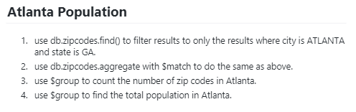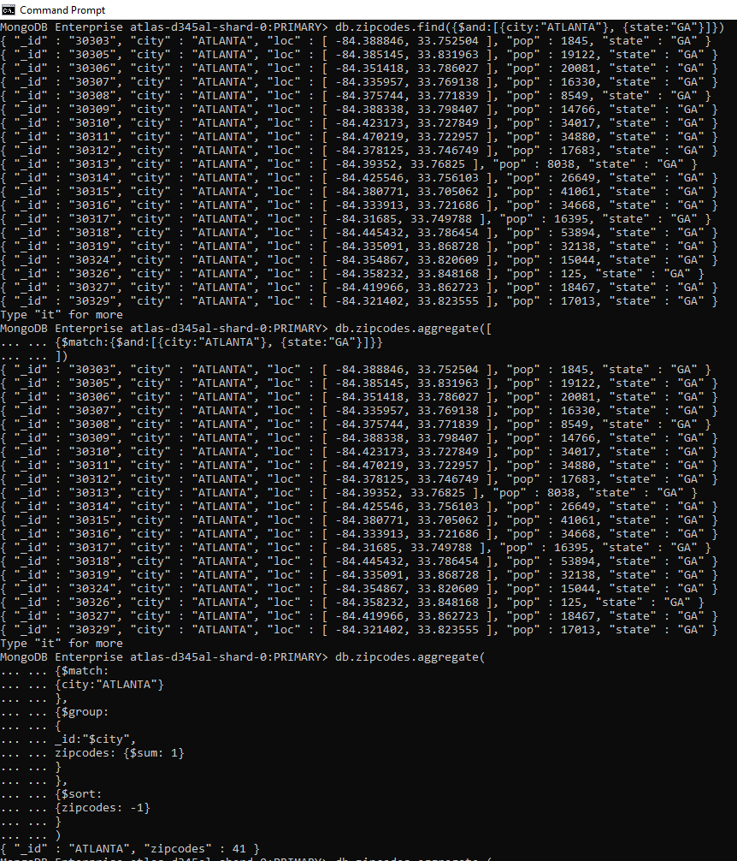

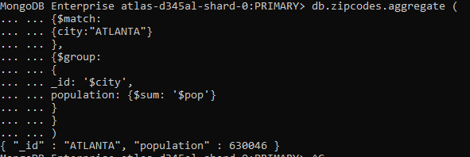

1. MongoDB Enterprise atlas-d345al-shard-0:PRIMARY> **db.zipcodes.find({$and:[{city:"ATLANTA"}, {state:"GA"}]})**

{ "_id" : "30303", "city" : "ATLANTA", "loc" : [ -84.388846, 33.752504 ], "pop" : 1845, "state" : "GA" }

{ "_id" : "30305", "city" : "ATLANTA", "loc" : [ -84.385145, 33.831963 ], "pop" : 19122, "state" : "GA" }

{ "_id" : "30306", "city" : "ATLANTA", "loc" : [ -84.351418, 33.786027 ], "pop" : 20081, "state" : "GA" }

{ "_id" : "30307", "city" : "ATLANTA", "loc" : [ -84.335957, 33.769138 ], "pop" : 16330, "state" : "GA" }

{ "_id" : "30308", "city" : "ATLANTA", "loc" : [ -84.375744, 33.771839 ], "pop" : 8549, "state" : "GA" }

{ "_id" : "30309", "city" : "ATLANTA", "loc" : [ -84.388338, 33.798407 ], "pop" : 14766, "state" : "GA" }

{ "_id" : "30310", "city" : "ATLANTA", "loc" : [ -84.423173, 33.727849 ], "pop" : 34017, "state" : "GA" }

{ "_id" : "30311", "city" : "ATLANTA", "loc" : [ -84.470219, 33.722957 ], "pop" : 34880, "state" : "GA" }

{ "_id" : "30312", "city" : "ATLANTA", "loc" : [ -84.378125, 33.746749 ], "pop" : 17683, "state" : "GA" }

{ "_id" : "30313", "city" : "ATLANTA", "loc" : [ -84.39352, 33.76825 ], "pop" : 8038, "state" : "GA" }

{ "_id" : "30314", "city" : "ATLANTA", "loc" : [ -84.425546, 33.756103 ], "pop" : 26649, "state" : "GA" }

{ "_id" : "30315", "city" : "ATLANTA", "loc" : [ -84.380771, 33.705062 ], "pop" : 41061, "state" : "GA" }

{ "_id" : "30316", "city" : "ATLANTA", "loc" : [ -84.333913, 33.721686 ], "pop" : 34668, "state" : "GA" }

{ "_id" : "30317", "city" : "ATLANTA", "loc" : [ -84.31685, 33.749788 ], "pop" : 16395, "state" : "GA" }

{ "_id" : "30318", "city" : "ATLANTA", "loc" : [ -84.445432, 33.786454 ], "pop" : 53894, "state" : "GA" }

{ "_id" : "30319", "city" : "ATLANTA", "loc" : [ -84.335091, 33.868728 ], "pop" : 32138, "state" : "GA" }

{ "_id" : "30324", "city" : "ATLANTA", "loc" : [ -84.354867, 33.820609 ], "pop" : 15044, "state" : "GA" }

{ "_id" : "30326", "city" : "ATLANTA", "loc" : [ -84.358232, 33.848168 ], "pop" : 125, "state" : "GA" }

{ "_id" : "30327", "city" : "ATLANTA", "loc" : [ -84.419966, 33.862723 ], "pop" : 18467, "state" : "GA" }

{ "_id" : "30329", "city" : "ATLANTA", "loc" : [ -84.321402, 33.823555 ], "pop" : 17013, "state" : "GA" }

Type "it" for more

1. MongoDB Enterprise atlas-d345al-shard-0:PRIMARY> **db.zipcodes.aggregate([**

**... ... {$match:{$and:[{city:"ATLANTA"}, {state:"GA"}]}}**

**... ... ])**

{ "_id" : "30303", "city" : "ATLANTA", "loc" : [ -84.388846, 33.752504 ], "pop" : 1845, "state" : "GA" }

{ "_id" : "30305", "city" : "ATLANTA", "loc" : [ -84.385145, 33.831963 ], "pop" : 19122, "state" : "GA" }

{ "_id" : "30306", "city" : "ATLANTA", "loc" : [ -84.351418, 33.786027 ], "pop" : 20081, "state" : "GA" }

{ "_id" : "30307", "city" : "ATLANTA", "loc" : [ -84.335957, 33.769138 ], "pop" : 16330, "state" : "GA" }

{ "_id" : "30308", "city" : "ATLANTA", "loc" : [ -84.375744, 33.771839 ], "pop" : 8549, "state" : "GA" }

{ "_id" : "30309", "city" : "ATLANTA", "loc" : [ -84.388338, 33.798407 ], "pop" : 14766, "state" : "GA" }

{ "_id" : "30310", "city" : "ATLANTA", "loc" : [ -84.423173, 33.727849 ], "pop" : 34017, "state" : "GA" }

{ "_id" : "30311", "city" : "ATLANTA", "loc" : [ -84.470219, 33.722957 ], "pop" : 34880, "state" : "GA" }

{ "_id" : "30312", "city" : "ATLANTA", "loc" : [ -84.378125, 33.746749 ], "pop" : 17683, "state" : "GA" }

{ "_id" : "30313", "city" : "ATLANTA", "loc" : [ -84.39352, 33.76825 ], "pop" : 8038, "state" : "GA" }

{ "_id" : "30314", "city" : "ATLANTA", "loc" : [ -84.425546, 33.756103 ], "pop" : 26649, "state" : "GA" }

{ "_id" : "30315", "city" : "ATLANTA", "loc" : [ -84.380771, 33.705062 ], "pop" : 41061, "state" : "GA" }

{ "_id" : "30316", "city" : "ATLANTA", "loc" : [ -84.333913, 33.721686 ], "pop" : 34668, "state" : "GA" }

{ "_id" : "30317", "city" : "ATLANTA", "loc" : [ -84.31685, 33.749788 ], "pop" : 16395, "state" : "GA" }

{ "_id" : "30318", "city" : "ATLANTA", "loc" : [ -84.445432, 33.786454 ], "pop" : 53894, "state" : "GA" }

{ "_id" : "30319", "city" : "ATLANTA", "loc" : [ -84.335091, 33.868728 ], "pop" : 32138, "state" : "GA" }

{ "_id" : "30324", "city" : "ATLANTA", "loc" : [ -84.354867, 33.820609 ], "pop" : 15044, "state" : "GA" }

{ "_id" : "30326", "city" : "ATLANTA", "loc" : [ -84.358232, 33.848168 ], "pop" : 125, "state" : "GA" }

{ "_id" : "30327", "city" : "ATLANTA", "loc" : [ -84.419966, 33.862723 ], "pop" : 18467, "state" : "GA" }

{ "_id" : "30329", "city" : "ATLANTA", "loc" : [ -84.321402, 33.823555 ], "pop" : 17013, "state" : "GA" }

Type "it" for more

1. MongoDB Enterprise atlas-d345al-shard-0:PRIMARY> **db.zipcodes.aggregate(**

**... ... {$match:**

**... ... {city:"ATLANTA"}**

**... ... },**

**... ... {$group:**

**... ... {**

**... ... _id:"$city",**

**... ... zipcodes: {$sum: 1}**

**... ... }**

**... ... },**

**... ... {$sort:**

**... ... {zipcodes: -1}**

**... ... }**

**... ... )**

**{ "_id" : "ATLANTA", "zipcodes" : 41 }**

1. MongoDB Enterprise atlas-d345al-shard-0:PRIMARY> **db.zipcodes.aggregate (**

**... ... {$match:**

**... ... {city:"ATLANTA"}**

**... ... },**

**... ... {$group:**

**... ... {**

**... ... _id: '$city',**

**... ... population: {$sum: '$pop'}**

**... ... }**

**... ... }**

**... ... )**

**{ "_id" : "ATLANTA", "population" : 630046 }**

**POPULATION BY STATE:**

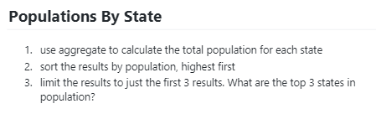

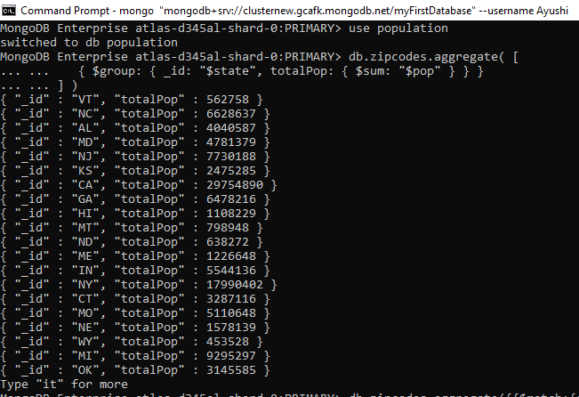

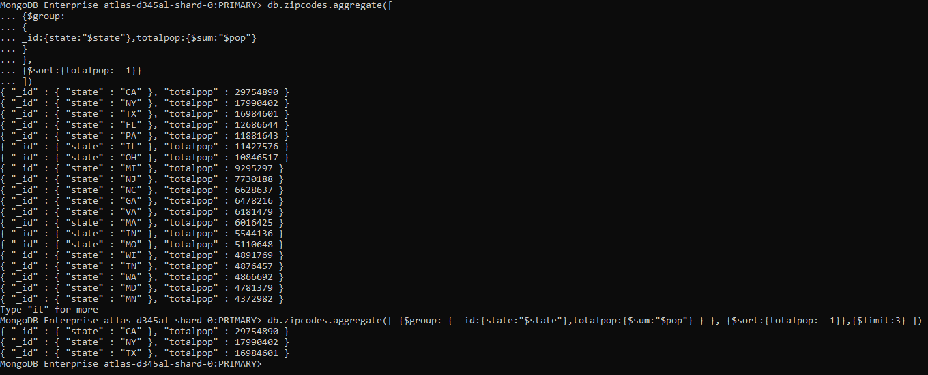

MongoDB Enterprise atlas-d345al-shard-0:PRIMARY> **use population**

**switched to db population**

1. MongoDB Enterprise atlas-d345al-shard-0:PRIMARY> **db.zipcodes.aggregate( [**

**... ... { $group: { _id: "$state", totalPop: { $sum: "$pop" } } }**

**... ... ] )**

{ "_id" : "VT", "totalPop" : 562758 }

{ "_id" : "NC", "totalPop" : 6628637 }

{ "_id" : "AL", "totalPop" : 4040587 }

{ "_id" : "MD", "totalPop" : 4781379 }

{ "_id" : "NJ", "totalPop" : 7730188 }

{ "_id" : "KS", "totalPop" : 2475285 }

{ "_id" : "CA", "totalPop" : 29754890 }

{ "_id" : "GA", "totalPop" : 6478216 }

{ "_id" : "HI", "totalPop" : 1108229 }

{ "_id" : "MT", "totalPop" : 798948 }

{ "_id" : "ND", "totalPop" : 638272 }

{ "_id" : "ME", "totalPop" : 1226648 }

{ "_id" : "IN", "totalPop" : 5544136 }

{ "_id" : "NY", "totalPop" : 17990402 }

{ "_id" : "CT", "totalPop" : 3287116 }

{ "_id" : "MO", "totalPop" : 5110648 }

{ "_id" : "NE", "totalPop" : 1578139 }

{ "_id" : "WY", "totalPop" : 453528 }

{ "_id" : "MI", "totalPop" : 9295297 }

{ "_id" : "OK", "totalPop" : 3145585 }

Type "it" for more

1. MongoDB Enterprise atlas-d345al-shard-0:PRIMARY> **db.zipcodes.aggregate([**

**... {$group:**

**... {**

**... _id:{state:"$state"},totalpop:{$sum:"$pop"}**

**... }**

**... },**

**... {$sort:{totalpop: -1}}**

**... ])**

{ "_id" : { "state" : "CA" }, "totalpop" : 29754890 }

{ "_id" : { "state" : "NY" }, "totalpop" : 17990402 }

{ "_id" : { "state" : "TX" }, "totalpop" : 16984601 }

{ "_id" : { "state" : "FL" }, "totalpop" : 12686644 }

{ "_id" : { "state" : "PA" }, "totalpop" : 11881643 }

{ "_id" : { "state" : "IL" }, "totalpop" : 11427576 }

{ "_id" : { "state" : "OH" }, "totalpop" : 10846517 }

{ "_id" : { "state" : "MI" }, "totalpop" : 9295297 }

{ "_id" : { "state" : "NJ" }, "totalpop" : 7730188 }

{ "_id" : { "state" : "NC" }, "totalpop" : 6628637 }

{ "_id" : { "state" : "GA" }, "totalpop" : 6478216 }

{ "_id" : { "state" : "VA" }, "totalpop" : 6181479 }

{ "_id" : { "state" : "MA" }, "totalpop" : 6016425 }

{ "_id" : { "state" : "IN" }, "totalpop" : 5544136 }

{ "_id" : { "state" : "MO" }, "totalpop" : 5110648 }

{ "_id" : { "state" : "WI" }, "totalpop" : 4891769 }

{ "_id" : { "state" : "TN" }, "totalpop" : 4876457 }

{ "_id" : { "state" : "WA" }, "totalpop" : 4866692 }

{ "_id" : { "state" : "MD" }, "totalpop" : 4781379 }

{ "_id" : { "state" : "MN" }, "totalpop" : 4372982 }

Type "it" for more

1. MongoDB Enterprise atlas-d345al-shard-0:PRIMARY> **db.zipcodes.aggregate([ {$group: { _id:{state:"$state"},totalpop:{$sum:"$pop"} } }, {$sort:{totalpop: -1}},{$limit:3} ])**

{ "_id" : { "state" : "CA" }, "totalpop" : 29754890 }

{ "_id" : { "state" : "NY" }, "totalpop" : 17990402 }

{ "_id" : { "state" : "TX" }, "totalpop" : 16984601 }

MongoDB Enterprise atlas-d345al-shard-0:PRIMARY>

**POPULATION BY STATE:**

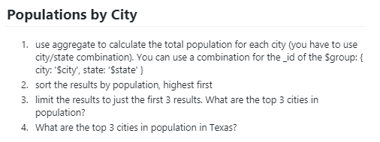

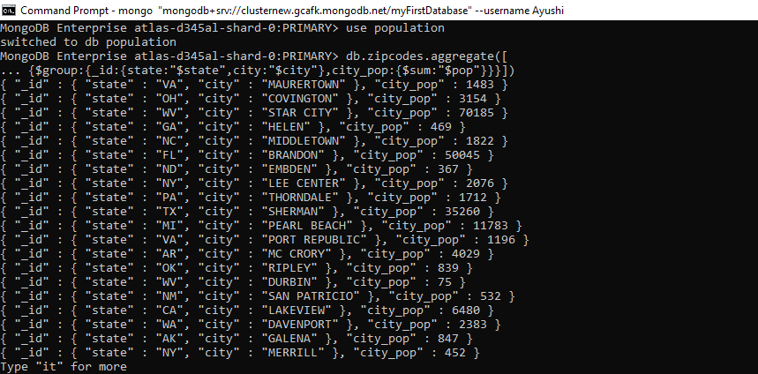

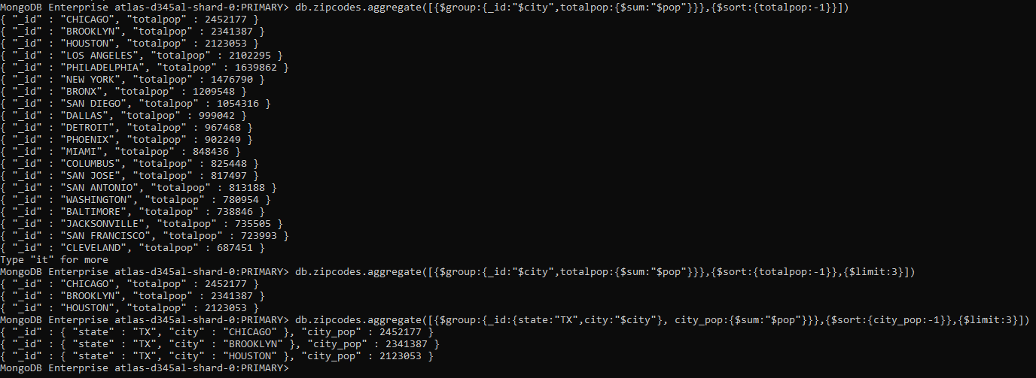

MongoDB Enterprise atlas-d345al-shard-0:PRIMARY> **use population**

**switched to db population**

1. MongoDB Enterprise atlas-d345al-shard-0:PRIMARY> **db.zipcodes.aggregate([**

**... {$group:{_id:{state:"$state",city:"$city"},city_pop:{$sum:"$pop"}}}])**

{ "_id" : { "state" : "VA", "city" : "MAURERTOWN" }, "city_pop" : 1483 }

{ "_id" : { "state" : "OH", "city" : "COVINGTON" }, "city_pop" : 3154 }

{ "_id" : { "state" : "WV", "city" : "STAR CITY" }, "city_pop" : 70185 }

{ "_id" : { "state" : "GA", "city" : "HELEN" }, "city_pop" : 469 }

{ "_id" : { "state" : "NC", "city" : "MIDDLETOWN" }, "city_pop" : 1822 }

{ "_id" : { "state" : "FL", "city" : "BRANDON" }, "city_pop" : 50045 }

{ "_id" : { "state" : "ND", "city" : "EMBDEN" }, "city_pop" : 367 }

{ "_id" : { "state" : "NY", "city" : "LEE CENTER" }, "city_pop" : 2076 }

{ "_id" : { "state" : "PA", "city" : "THORNDALE" }, "city_pop" : 1712 }

{ "_id" : { "state" : "TX", "city" : "SHERMAN" }, "city_pop" : 35260 }

{ "_id" : { "state" : "MI", "city" : "PEARL BEACH" }, "city_pop" : 11783 }

{ "_id" : { "state" : "VA", "city" : "PORT REPUBLIC" }, "city_pop" : 1196 }

{ "_id" : { "state" : "AR", "city" : "MC CRORY" }, "city_pop" : 4029 }

{ "_id" : { "state" : "OK", "city" : "RIPLEY" }, "city_pop" : 839 }

{ "_id" : { "state" : "WV", "city" : "DURBIN" }, "city_pop" : 75 }

{ "_id" : { "state" : "NM", "city" : "SAN PATRICIO" }, "city_pop" : 532 }

{ "_id" : { "state" : "CA", "city" : "LAKEVIEW" }, "city_pop" : 6480 }

{ "_id" : { "state" : "WA", "city" : "DAVENPORT" }, "city_pop" : 2383 }

{ "_id" : { "state" : "AK", "city" : "GALENA" }, "city_pop" : 847 }

{ "_id" : { "state" : "NY", "city" : "MERRILL" }, "city_pop" : 452 }

Type "it" for more

1. MongoDB Enterprise atlas-d345al-shard-0:PRIMARY> **db.zipcodes.aggregate([{$group:{_id:"$city",totalpop:{$sum:"$pop"}}},{$sort:{totalpop:-1}}])**

{ "_id" : "CHICAGO", "totalpop" : 2452177 }

{ "_id" : "BROOKLYN", "totalpop" : 2341387 }

{ "_id" : "HOUSTON", "totalpop" : 2123053 }

{ "_id" : "LOS ANGELES", "totalpop" : 2102295 }

{ "_id" : "PHILADELPHIA", "totalpop" : 1639862 }

{ "_id" : "NEW YORK", "totalpop" : 1476790 }

{ "_id" : "BRONX", "totalpop" : 1209548 }

{ "_id" : "SAN DIEGO", "totalpop" : 1054316 }

{ "_id" : "DALLAS", "totalpop" : 999042 }

{ "_id" : "DETROIT", "totalpop" : 967468 }

{ "_id" : "PHOENIX", "totalpop" : 902249 }

{ "_id" : "MIAMI", "totalpop" : 848436 }

{ "_id" : "COLUMBUS", "totalpop" : 825448 }

{ "_id" : "SAN JOSE", "totalpop" : 817497 }

{ "_id" : "SAN ANTONIO", "totalpop" : 813188 }

{ "_id" : "WASHINGTON", "totalpop" : 780954 }

{ "_id" : "BALTIMORE", "totalpop" : 738846 }

{ "_id" : "JACKSONVILLE", "totalpop" : 735505 }

{ "_id" : "SAN FRANCISCO", "totalpop" : 723993 }

{ "_id" : "CLEVELAND", "totalpop" : 687451 }

Type "it" for more

1. MongoDB Enterprise atlas-d345al-shard-0:PRIMARY> **db.zipcodes.aggregate([{$group:{_id:"$city",totalpop:{$sum:"$pop"}}},{$sort:{totalpop:-1}},{$limit:3}])**

{ "_id" : "CHICAGO", "totalpop" : 2452177 }

{ "_id" : "BROOKLYN", "totalpop" : 2341387 }

{ "_id" : "HOUSTON", "totalpop" : 2123053 }

1. MongoDB Enterprise atlas-d345al-shard-0:PRIMARY> **db.zipcodes.aggregate([{$group:{_id:{state:"TX",city:"$city"}, city_pop:{$sum:"$pop"}}},{$sort:{city_pop:-1}},{$limit:3}])**

{ "_id" : { "state" : "TX", "city" : "CHICAGO" }, "city_pop" : 2452177 }

{ "_id" : { "state" : "TX", "city" : "BROOKLYN" }, "city_pop" : 2341387 }

{ "_id" : { "state" : "TX", "city" : "HOUSTON" }, "city_pop" : 2123053 }

MongoDB Enterprise atlas-d345al-shard-0:PRIMARY>

**BONUS:**

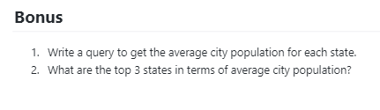

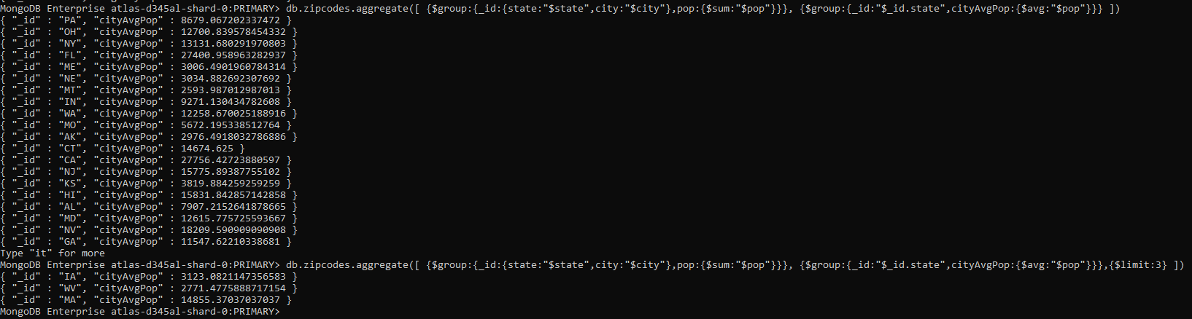

1. MongoDB Enterprise atlas-d345al-shard-0:PRIMARY> **db.zipcodes.aggregate([ {$group:{_id:{state:"$state",city:"$city"},pop:{$sum:"$pop"}}}, {$group:{_id:"$_id.state",cityAvgPop:{$avg:"$pop"}}} ])**

{ "_id" : "PA", "cityAvgPop" : 8679.067202337472 }

{ "_id" : "OH", "cityAvgPop" : 12700.839578454332 }

{ "_id" : "NY", "cityAvgPop" : 13131.680291970803 }

{ "_id" : "FL", "cityAvgPop" : 27400.958963282937 }

{ "_id" : "ME", "cityAvgPop" : 3006.4901960784314 }

{ "_id" : "NE", "cityAvgPop" : 3034.882692307692 }

{ "_id" : "MT", "cityAvgPop" : 2593.987012987013 }

{ "_id" : "IN", "cityAvgPop" : 9271.130434782608 }

{ "_id" : "WA", "cityAvgPop" : 12258.670025188916 }

{ "_id" : "MO", "cityAvgPop" : 5672.195338512764 }

{ "_id" : "AK", "cityAvgPop" : 2976.4918032786886 }

{ "_id" : "CT", "cityAvgPop" : 14674.625 }

{ "_id" : "CA", "cityAvgPop" : 27756.42723880597 }

{ "_id" : "NJ", "cityAvgPop" : 15775.89387755102 }

{ "_id" : "KS", "cityAvgPop" : 3819.884259259259 }

{ "_id" : "HI", "cityAvgPop" : 15831.842857142858 }

{ "_id" : "AL", "cityAvgPop" : 7907.2152641878665 }

{ "_id" : "MD", "cityAvgPop" : 12615.775725593667 }

{ "_id" : "NV", "cityAvgPop" : 18209.590909090908 }

{ "_id" : "GA", "cityAvgPop" : 11547.62210338681 }

Type "it" for more

1. MongoDB Enterprise atlas-d345al-shard-0:PRIMARY> **db.zipcodes.aggregate([ {$group:{_id:{state:"$state",city:"$city"},pop:{$sum:"$pop"}}}, {$group:{_id:"$_id.state",cityAvgPop:{$avg:"$pop"}}},{$limit:3} ])**

{ "_id" : "IA", "cityAvgPop" : 3123.0821147356583 }

{ "_id" : "WV", "cityAvgPop" : 2771.4775888717154 }

{ "_id" : "MA", "cityAvgPop" : 14855.37037037037 }

MongoDB Enterprise atlas-d345al-shard-0:PRIMARY>